**DAILY ONLINE ACTIVITIES SUMMARY**

|  |  |  |  |  |  |  |  |
| --- | --- | --- | --- | --- | --- | --- | --- |
| **Date:** | **19/06/2020** | | | | **Name:** | **Syed Rabeya Aamir** | |
| **Sem & Sec** | **8th B** | | | | **USN:** | **4AL16CS112** | |
| Online Test Summary | | | | | | | |
| **Subject** | | **BDA** | | | | | |
| **Max. Marks** | | **30** | | **Score** | | **14** | |
| Certification Course Summary | | | | | | | |
| **Course** | **DEVELOPING MACHINE LEARNING APPLICATION.** | | | | | | |
| **Certificate Provider** | | | **Aws** | **Duration** | | | **3 hrs** |
| Coding Challenges | | | | | | | |
| **Problem Statement:**  **1)**  Python program to print prime factors. | | | | | | | |
| **Status: Solved** | | | | | | | |
| **Uploaded the report in Github** | | | | **YES** | | | |
| **If yes Repository name** | | | | **rabeya** | | | |
| **Uploaded the report in slack** | | | | **YES** | | | |

**ONLINE TEST:**

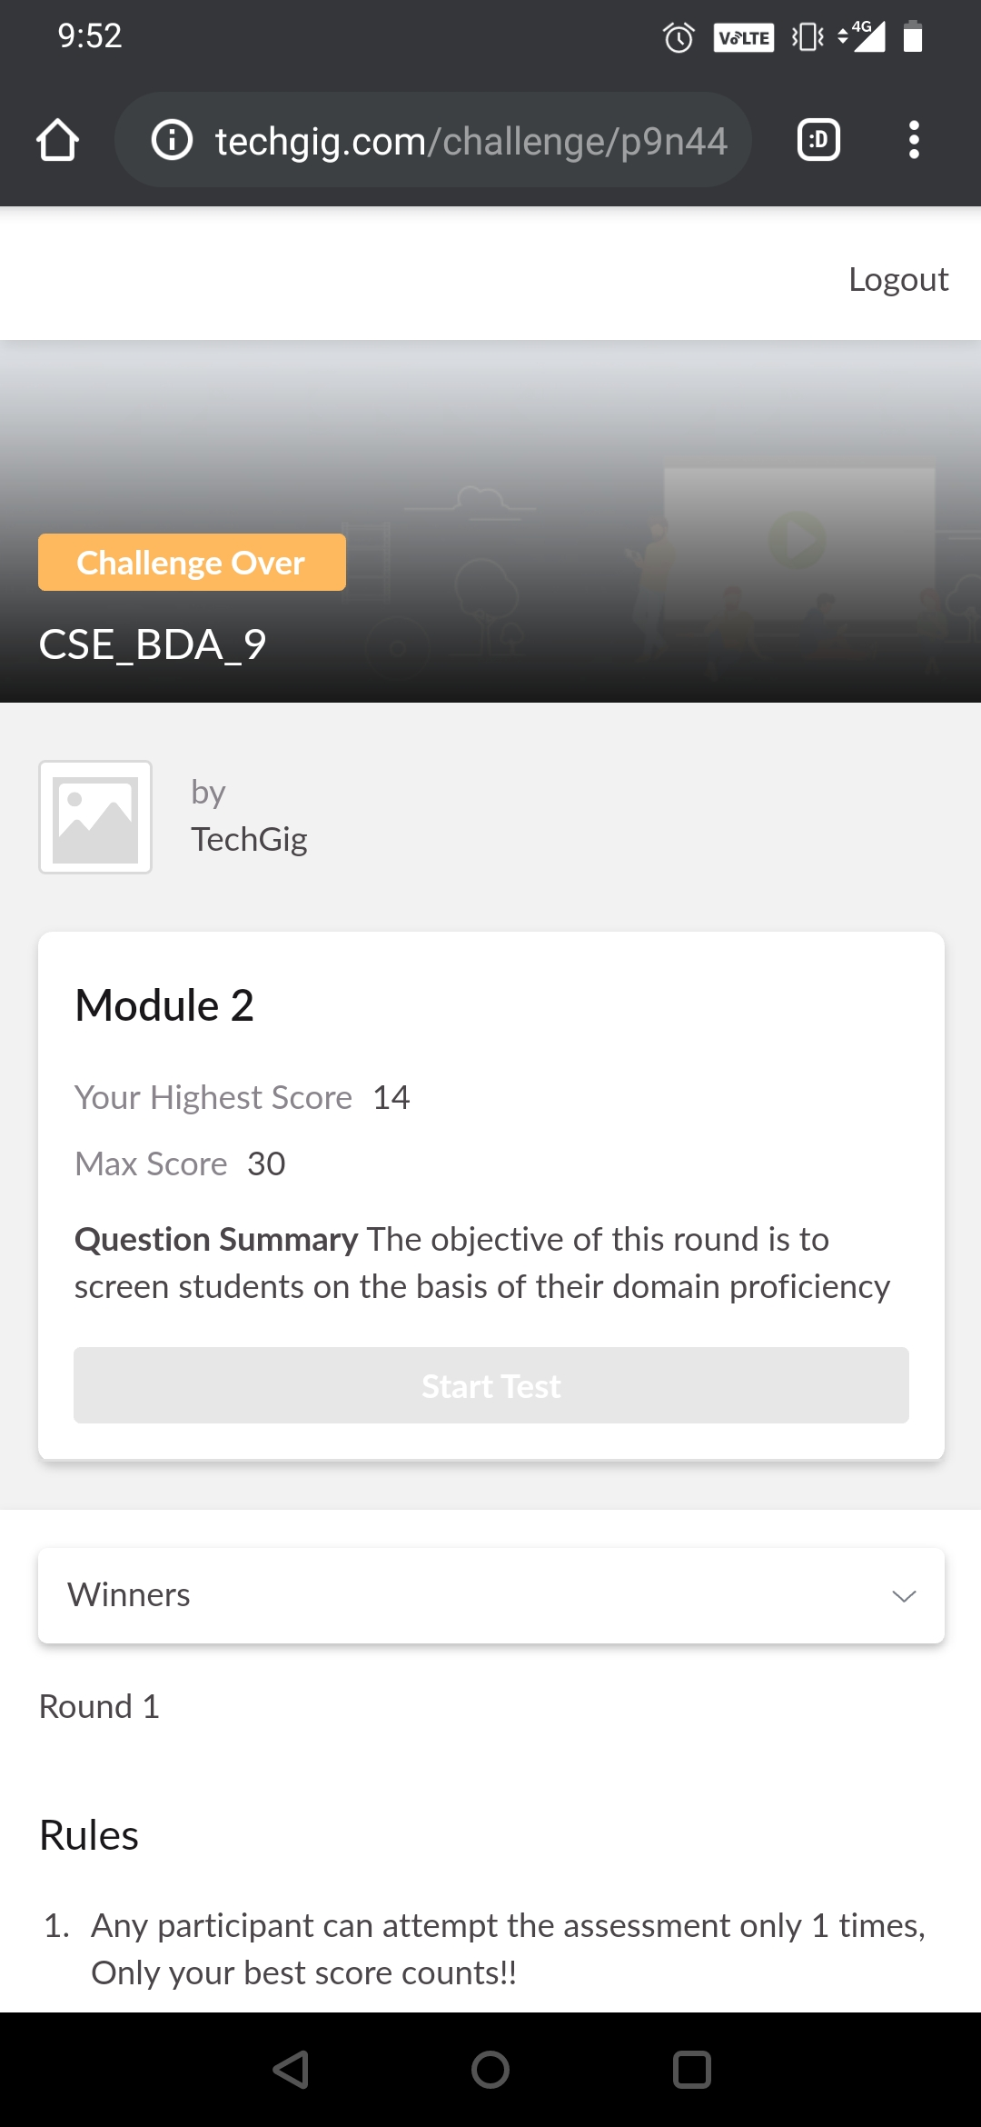

**Certification Course Details:**

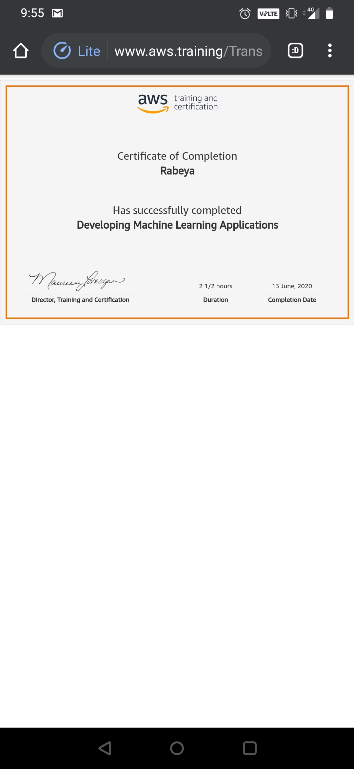

# CODE:

Program no:1

# Python program to print prime factors

import math

def primeFactors(n):

while n % 2 == 0:

print 2,

n = n / 2

for i in range(3,int(math.sqrt(n))+1,2):

while n % i== 0:

print i,

n = n / i

if n > 2:

print n

n = 315

primeFactors(n)